

Name: | Waleed Afzal
Roll No | 23P-0566
Course/Section | Software Engineering/5C
Assignment | Number 3
Date: | 29/11/2025

Q1 — Software Planning Scenario
Task 1 — Test Plan Development
Test Objectives
- Functional: Ensure real-time seat tracking, prerequisite checks, timetable conflict detection, and faculty schedule updates work correctly.
- Non-functional: Verify system performance during peak hours, security of student data, and scalability for future growth.
Scope
- In-scope: Enrollment process, seat tracking, prerequisite validation, timetable conflict detection.
- Out-of-scope: Payment gateway, external LMS integration.
Testing Levels
- Unit Testing: Individual modules like seat tracking and prerequisite validation.
- Integration Testing: Interaction between modules (e.g., timetable and enrollment).
- System Testing: Full system behavior under normal and peak loads.
- Acceptance Testing: Final check by university stakeholders.
Testing Approaches
- Black-box: Validate inputs and outputs without looking at code.
- White-box: Check internal logic for critical modules.
Entry & Exit Criteria
- Entry: Code completed, unit tests passed, test environment ready.
- Exit: All planned tests executed, major defects fixed, performance meets standards.
Risk Assessment & Mitigation
- Risk: Server overload during peak → Mitigation: Load testing and scalable architecture.
- Risk: Data breach → Mitigation: Strong encryption and security audits.
Resource Allocation
- Test Manager, QA Engineers, Automation Tester, Performance Tester.
Testing Schedule & Deliverables
- Week 1–2: Unit tests
- Week 3–4: Integration tests
- Week 5: System tests
- Week 6: Acceptance tests
Deliverables: Test cases, test reports, defect logs.

Task 2 — Review Strategy Mapping
SDLC Phase | Review Type | Why Appropriate | Participants | Expected Outcome
Requirements | Business Review | Ensures alignment with university policies | Facilitator, Author, Recorder, Reviewer | Detect missing requirements
Planning | Management Review | Confirms project goals, resources, and risks | Facilitator, Author, Recorder | Clear project plan and risk control
Design | Technical Review | Validates architecture and scalability | Facilitator, Author | Find design flaws
Development | Walkthrough | Early detection of coding issues | Author, Recorder | Minor logic errors
Testing | Inspection | Formal check of test cases and scripts | Recorder, Reviewer | Ensure complete and correct test coverage
Deployment | Management Review | Confirms readiness and risk handling | Facilitator, Author, Recorder, Reviewer | Go/No-Go decision for release

Task 3 — Constraints, Risks & Planning Decisions
Technical Constraints
- Must support real-time updates.
- Limited server capacity.
- Integration with existing university database.
- Secure login with strong password policy.
- Mobile compatibility.
Organizational Constraints
- Fixed budget.
- Limited testing team.
- Strict academic calendar deadlines.
- Compliance with university IT policies.
- Limited training time for staff.
Major Risks & Mitigation
- Peak load failure → Perform stress testing.
- Data security breach → Apply encryption and regular audits.
- Integration issues → Early API testing.
- Schedule delays → Use agile sprints and buffer time.
- Requirement changes → Maintain change control process.
- Poor usability → Conduct user acceptance testing.
- Hardware failure → Backup servers and disaster recovery plan.

Q2 — Black-Box Test Design
Scenario: The CEMS login module enforces strong credential validation and account security.
Task 1 — EC & BVA Test Design
We will use Equivalence Partitioning (EP) and Boundary Value Analysis (BVA) for username, password, and failed attempts.
Partitions
- Username
  - Valid: 5–15 characters, alphanumeric
  - Invalid: Less than 5 or more than 15 characters, special characters only
- Password
  - Valid: At least 8 characters, includes uppercase, digit, and special character
  - Invalid: Missing any of these rules
- Failed Attempts
  - Valid: 0–4 attempts
  - Invalid: 5 or more → Account locked
Sample Test Cases (8 cases)
TC# | Input | Expected Result
1 | Username = “john123”, Password = “Pass@123”, Attempts = 0 | Login successful
2 | Username = “jo”, Password = “Pass@123”, Attempts = 0 | Error: Invalid username
3 | Username = “john123”, Password = “pass1234”, Attempts = 0 | Error: Missing uppercase & special char
4 | Username = “john123”, Password = “Pass@123”, Attempts = 4 | Login successful
5 | Username = “john123”, Password = “Pass@123”, Attempts = 5 | Account locked
6 | Username = “john1234567890123”, Password = “Pass@123”, Attempts = 0 | Error: Username too long
7 | Username = “john123”, Password = “Pass1234”, Attempts = 0 | Error: Missing special character
8 | Username = “john123”, Password = “@Pass123”, Attempts = 0 | Login successful

Task 2 — Decision Table Construction
Conditions
- Username Valid? (Yes/No)
- Password Valid? (Yes/No)
- Failed Attempts (0–4 or ≥5)
Actions
- Success
- Error
- Account Locked
Rule | Username | Password | Attempts | System Response
1 | Yes | Yes | 0-4 | Success
2 | Yes | Yes | >=5 | Account Locked
3 | Yes | No | Any | Error
4 | No | Yes | Any | Error
5 | No | No | Any | Error

Q3 — Black-Box Test Design
Task 1 — State Diagram
Draw a state machine diagram representing:
• States
• Transitions
• Events & actions
Follow proper UML notation.

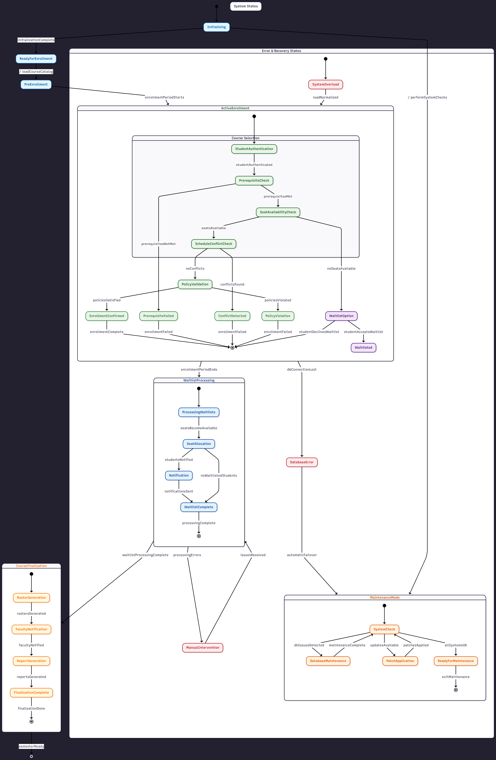
Task 2 — Multi-Step Transition Test Cases
create 3 test cases showing how the system moves through different states based on user actions.
Test Case 1:
Step | Start State | Input | Expected Output | Finish State
1 | Logged Out | Enter valid username & password | Logged In | Logged In
2 | Logged In | Click Logout | Logged Out | Logged Out

Test Case 2:
Step | Start State | Input | Expected Output | Finish State
1 | Logged Out | Enter wrong password 5 times | Locked | Locked
2 | Locked | Admin unlocks account | Logged Out | Logged Out

Test Case 3:
Step | Start State | Input | Expected Output | Finish State
1 | Logged In | No activity for 10 minutes | Inactive | Inactive
2 | Active | User clicks on dashboard | Logged In | Logged In

Q4 — Test Case Writing & Defect Analysis
Task 1 — Functional & Non-Functional Test Cases
Functional Test Cases
- Check Seat Availability:
  - Input: Select a course
  - Expected Result: Show correct available seats
- Validate prerequisites
  - Input: Enroll in advanced course
  - Expected Result: Error if prerequisites are not met
- Detect timetable clash
  - Input: Add two courses with same time
  - Expected Result: Show conflict message
- Successful enrollment
  - Input: Select valid course
  - Expected Result: Enrollment confirmed
- Drop a course
  - Input: Remove enrolled course
  - Expected Result: Course removed successfully
- Update faculty schedule
  - Input: Change class timing
  - Expected Result: Updated schedule visible
Non-Functional Test Cases
  - Performance under load:
- Expected Result: System handles 1000 users

  - Performance under load:
- Expected Result: System handles 1000 users

  - Stress test:
- Expected Result: Push beyond peak load

  - Usability:
- Expected Result: Check UI clarity

Task 2 — Defect Classification
Defect | Type | Severity | Origin Phase | Review Type
Seat count not updating | Functional | High | Development | Walkthrough
Login fails with valid credentials | Functional | Critical | Development | Inspection
Slow response during peak | Performance | High | Testing | Management Review
Missing prerequisite check | Functional | High | Design | Technical Review
UI text overlaps | Usability | Medium | Design | Technical Review

